LYONS
CENTRAL SCHOOL DISTRICT



COACHES HANDBOOK

(2018-2019)

TABLE OF CONTENTS
FORMS

- Important Dates:

- New Sports Information:

- Notes from the A.D. (Hazing)

- Coaches Information

- Coaches Checklist

- Parental permission forms for selective classification:
For both Female & Male

- Medical Claim Form: Injury reporting form.

- Removal / Quitting of Athlete Form:

- Athlete Outstanding suspensions:

- Season End Summary:

- Lyons Central School Roster form:
You do not need to use this form, there for your convenience.

- Attendance Form: There for your convenience.

- Thunderstorm Safety & Outdoor Events:

- Scholar / Athlete Team Award: NYSPHSAA.org (Scholar Athlete Form)

- Building Request Forms: (This is done online – Lyonscsd.org/intranet)

XVIII . Work Order Forms: Turn in to me first! (This will soon be online)

XIX. Evaluation Forms: Upon Request

- Coaches: Reading Material – Upon Request

IMPORTANT ATHLETIC DATES
- August 7th Fall Coaches meeting:
        - 5:00 – Transportation Conference Room
        - 6:00 – Parent Meeting / Meet with coaches first
        - 6:30 – Mr. Veeder’s Presentation
          - Athletic Schedules – Waynefingerlakesleague.org
          - Athletic Policy Revisions
          - Physicals, Concussion Management
          - Picture schedule
        - 6:45 – Scott Fitch:
        - 7:30 – Dismissed.

- August 9th Athlete Placement Process (APP) Testing – 9:00am at the MS/HS
        - Paperwork due to me by August 7th.
- August 13th Fall sports Season begins – J.V. & Varsity Teams
        - Mod. “A” Football begins August 20th
- August 27th Photo Day for fall J.V. and Varsity Sports – Time = 7:45 – 11:30sh

- Sept. 5th All Modified sports can begin – Photo Day is: September 18th @ 2:40

- October Homecoming Week: October 8th – October 13th

- October 16th Winter Coaches meeting.

- October 18th Athletic Placement Process (APP) Testing: 3:15 (All paperwork needs to be completed)
        - Paperwork due to me by October 12th.
- October 22nd Modified Winter I begins (Modified Boys’ Basketball)

- November 5th J.V. & Varsity winter sports begin

- November - TBD Photo Day: Modified, J.V. & Varsity – Time = TBD

- January 7th Modified Wrestling begins:

- January 7th Modified Girls’ Basketball begins:

- January - TBD Photo Day: Modified Girls Basketball & Wrestling – Time TBD

- February 26th Spring Coaches meeting.

- February 28th APP Athletic Placement Process Testing: 3:15 (All paperwork needs to be in.)
        - Paperwork due to me by February 26th
- March 4th J.V. & Varsity spring sports begin

- March - TBD J.V. & Varsity Photo Day – Time = TBD

- March 8, 9, 10 Musical Performance

- March 18th Modified spring sports begin

- March – TBD Photo Day: Modified Sports – Time TBD

- March 20-24 Sr. Trip

- June 17th Moving-Up Assembly:

New/Old Information:

- Academic Ineligibility Policy
- Illegal Substance revisions (Guilty by Association)
- Drug Evaluation may be by any physician
Lyons Athletics
To: All Sports Coaches:
Re: Important Information
Basic Information
- Hazing – Becoming a very serious topic – I have sent you a recent article
- Supervision – All times!
- Medical Forms – First Aid Kit - Must have with you at practice at all times!
- Music – Must be appropriate (You must proof it) we work for our community!
- Media – Call in every game (Train your players what to say). Not to be used for motivation!
- Program evaluations: Meeting with A.D. with entire coaching staff!
- Transportation – Schedule are on our website – please consult with the person you ride with so the times are the same!
- Uniforms – Taking care of them? An inventory must be turned in at the end of your season!
- Picture day: See page 3 for more information
- Vouchers – Give to Kim Sholly!
- Rosters – Due to Mr. Veeder within 1 week after the start of the season.
- APP – Dates are scheduled on the previous page. All paperwork needs to be completed in order for any student to be tested. Also very important you communicate with the parents your philosophy of a younger athlete moving up in your program
- Outstanding obligations. Please give to me a list of outstanding obligations that you may have. You are to do your very best in getting all equipment returned before I get involved including letters and parent phone calls. After that, I will then be glad to assist you.
- Requisitions: Do not order without requisitions & approval from A.D.
- Philosophy – Parent meeting – MANDATORY.
- Try-outs & cuts: NO list! – Meet with each kid personally.
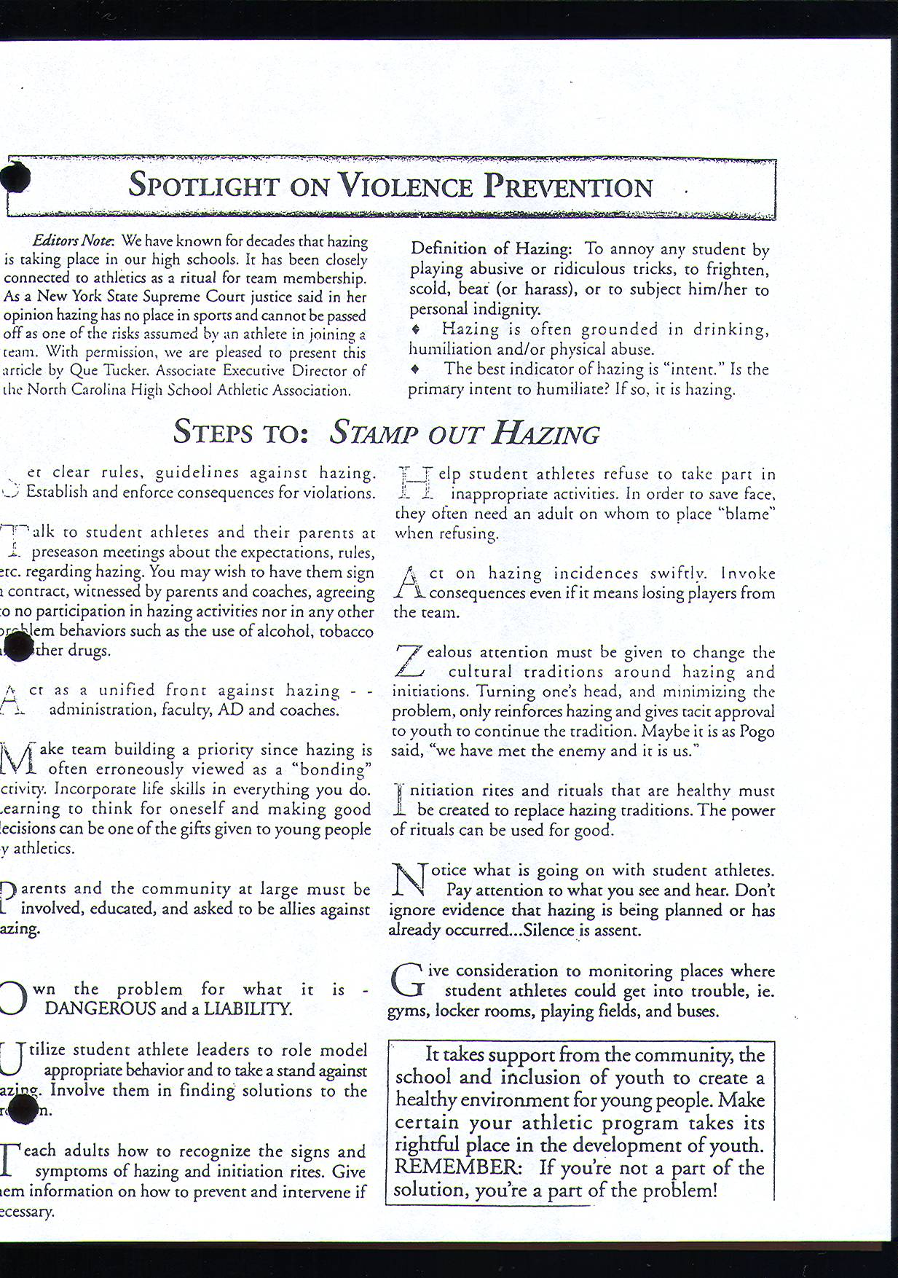
- Moving-Up Assembly: June 11th Athletic suspension: After an athlete has served his/her suspension please send me an e-mail or a memo so I can take him/her off our list! PROFESSIONALISM: Dress, attitude, behavior. Be able to work under pressure - (when you can do this that is a sign of a true professional).

Notes from the A.D.:

- Alarm system: Security-Supervision: School is closed at 3:30!
Practices should not begin prior to 3:15 from Monday – Thursday without special permission.

- No one in gym/field or at practice without coach supervision.

- You are responsible for setting up your personal equipment for games and practices. In addition, you are also responsible for making sure all music that is being played is appropriate.

- Stay at school until athletes are gone or accounted for, 15 minutes for a scheduled practice, the entire time for a rescheduled practice/game.

- Enter and exit through East doors! (Doors facing Clyde)

- No cleats in the school or on the bus!

- Provide athletes plenty of water breaks! (If possible, in a shaded area)

- Keep locker room neat, so it may be cleaned every day!

- In case of lightning/thunder, remove players from field to the bus or nearby school.
(30-minutes)

- If anything unusual happens please inform A.D. (Injury, fight, irate parent)
***** Remember you are mandated to report any abuse by a parent or whomever!

- If parent has a problem, set up an appointment with them to meet with you, don’t try
and take care of it on the field!!

- Sportsmanship: Reinforce good sportsmanship – Correct poor sportsmanship

- Evaluations: Will be done per program at end of season!

- A.D.: Requisition – Do not order anything without putting it down on a requisition form and approval.

- E-mail: Please check frequently – When game changes are made you should get an E-mail through rSchool if you register for the NOTIFY ME tab.

- Handbooks – Cover new athletic training rules – Athletic Handbook

- Unpaid coaching assistants (Volunteer Coaches): Need to be board approved.

MEMO

TO: SPORTS COACHES

FROM: STEPHEN VEEDER

DATE: August 7th, 2018

Please review the following checklist below. Make sure you have all of the necessary paperwork, medical kit w/ supplies, etc. If you have any individual rules that you enforce during your season, make sure they are in writing and approved by me before you send them out to your players and parents/guardians. Every coach should have something in writing. You are responsible for relaying to athletes and parents your: (Parent Meeting)

- Coaching philosophy.
- Expectations for their child and the team.
- Location & Times of all practices and games. (1 ½ wks. In advance)
- Team requirement: practices, special equipment, etc.
- Procedures to follow should their child be injured during participation.
- Disciplinary action that may result in their child being denied the right to participate.
- Sportsmanship: What you expect from your athletes and parents.
- Eligibility: Discuss the eligibility policy to your athletes and parents.

Let me know if I can be of any further assistance, I am looking forward to working with all of you.

Head coaches: You should relay your expectations to the modified and J.V. coaches at the beginning of their season, maintain close contact, and communicate with them throughout the entire season!

Coaches checklist

Pre-Season:

1.______ List of students signed up for the program with phone numbers, addresses, uniform numbers, and
anything else you want to appear on your team roster.
(Turn this in to me within 1 week)

2. ______ Necessary equipment: clock, score book, uniforms, mouth guards, etc.
Inspect your playing area to make sure everything is ready to go!

3. ______ Medical Kit stocked and ready. (Have ice at all times)

4. ______ The District’s Student Accident Insurance Form. (Athletic Handbook)

5. ______ Emergency Information Card. (Athletic Handbook)

6. ______ Necessary keys to access locker room, equipment room, and facilities.

7. ______ Individual coaching rules in writing for athletes, and copy to Athletic Director.
Provide date to A.D. of when your parent meeting will be.

8. ______ Game schedule with departure times! Please review and return to S. Veeder

9 . _____ You have completed all certification requirements and given to A.D. It is your
responsibility to make sure all your coaching requirements are fulfilled. If you
need assistance, then contact me & I will be glad to assist you.

10. _____ Disqualification forms. Please see me if you do not have any copies.
(On the back of the vouchers)

11. _____ Physicals: Be sure all players have had a physical prior to participation of any
kind. NO student may participate without a physical and their health history
form completed by a medical professional. Please refer to our new program online in infinite campus.

13. _____ Athletic Placement Process (APP): Any player going through this procedure can not
participate until the process is completed and approved. So, identify the
the athletes and refer them to me so we can get the testing done and they
can start practice on time. I must approve the athlete before they are invited!

14. _____ Injuries: Fill out NEW accident report forms immediately & return to Nurse
Harper. On these forms just stat what happened, you are not a Dr.! Make a
copy for yourself and the A.D.

15. _____ New students: If you have a new student please check with me for eligibility.

16. _____ Please let me know if you need help in finding a scorekeeper, timer, officials,
otherwise this is your responsibility.

During-Season:

1. ______ Review with players: Expectations that you have for them.

2. ______ Keep regular check on Med. Kit and make sure you have everything you need.

3. ______ Report to A. D. any injuries, change in player status, problems, etc.

4. ______ Model expectation of your athletes at all times.

5.______ Check your goals: Are you accomplishing them? Identify problems? Do you
need intervention, help from the A.D.? Are you maintaining variety in your
practices to stimulate motivation? What is working for your team?

6.______ Maintain frequently communications with the Athletic Director, if not daily!

7.______ Review emergency procedures, first aid and CPR techniques!

Post-Season:

1.End of the season meeting and report: Schedule a meeting with the A.D. within two weeks after your season ends. Please arrange a time where you and the rest of your staff can sit down and meet with me to discuss the entire program & to assess what we are doing well & how we may improve next year.
See Checklist form!

- Player Status- # of years played for that level, earned letter/pin, missing equipment (uniforms, practice gear, etc.)
- Award winners that I need to get for the end of the year banquet.
- Requisitions for next year.
- Coaches should reflect on the following at the conclusion of the season. Did we meet our goals? What hat are your goals for next preseason/season? Did you identify strengths or weaknesses you would like to work on? What did you like? What didn’t you like? Will there be any changes in your program next year? How can the A.D. help you with your program? Etc. (If anybody does player evaluations please share with me if you would like.)
- Complete inventory of equipment, materials, and supplies. Please rate their condition: Good, Fair, or Poor.
F. Have fun!

Thank you for your hard work and working with the Lyons Athletic Department!

LYONS CENTRAL SCHOOL DISTRICT
ACCIDENT/INCIDENT PARENT NOTIFICATION FORM

_____________________________________ was injured on ________________at_______ AM PM.
Please be advised:
Place Where Injury Occurred: Body Injury Site:
 | Home School |  |  |  |  |  |  |  |  |  | Locker Area |  |  |  |  |  |  |  |  |  |  |  |  | Head |  |  |  |  |  | Ear |  |  |  |  | Eye |  |  |  |  |  |  | Nose
 | Away School |  |  |  |  |  |  |  |  |  | Field/Court/Gym |  |  |  |  |  |  |  |  |  |  |  |  | Mouth |  |  |  |  |  | Tooth |  |  |  |  | Jaw |  |  |  |  |  |  | Neck
 | Bus/Bus stop |  |  |  |  |  |  |  |  |  | Classroom/Hall |  |  |  |  |  |  |  |  |  |  |  |  | Chest/Rib |  |  |  |  |  | Face |  |  |  |  | Back |  |  |  |  |  |  | Abdomen
 | Playground |  |  |  |  |  |  |  |  |  | Cafeteria |  |  |  |  |  |  |  |  |  |  |  |  | Genitals |  |  |  |  |  | Extremity (specify below):
 | Other (specify): |  |  |  |  |  |  |  |  |  |  |  |  |  |  |  |  |  |  |  |  |  |  |  |  |  |  |  |  |  | Left |  |  | Right
Activity: |  |  |  |  |  |  |  |  |  |  |  |  |  |  |  |  |  |  |  |  |  |  |  |  |  |  |  |  | Upper: |  |  |  | Lower:
Sport: |  |  |  |  |  |  |  |  |  |  |  |  |  |  |  |  |  |  |  |  |  |  |  |  |  |  |  |  |  | Shoulder |  |  |  |  |  | Hip
 | Varsity |  |  |  |  |  |  |  |  | Girls Boys Coed |  |  |  |  |  |  |  |  |  |  |  |  |  |  |  |  |  |  |  | Arm |  |  |  |  |  | Thigh
 | JV |  |  |  |  |  |  |  | Interscholastic |  |  |  |  |  |  |  |  |  |  |  |  |  |  |  |  |  |  |  |  | Elbow |  |  |  |  |  | Knee
 | Modified |  |  |  |  |  |  |  |  | Intramural |  |  |  |  |  |  |  |  |  |  |  |  |  |  |  |  |  |  |  | Hand |  |  |  |  |  | Shin
Type of Injury: |  |  |  |  |  |  |  |  |  |  |  |  |  |  |  |  |  |  |  |  |  |  |  |  |  |  |  |  |  | Wrist |  |  |  |  |  | Ankle
 | Fall |  |  |  |  |  |  |  |  | Altercation |  |  |  |  |  |  |  |  |  |  |  |  |  |  |  |  |  |  |  | Finger # __ |  |  |  |  |  | Foot
 | Collision |  |  |  |  |  |  |  |  | Human Bite |  |  |  |  |  |  |  |  |  |  |  |  |  |  |  |  |  |  |  |  |  |  |  |  |  | Toe # ___
 | Other (specify): |  |  |  |  |  |  |  |  |  |  |  |  |  |  |  |  |  |  |  |  |  |  |  |  |  |  |  | (Thumb = #1) (Pinky = #5) |  |  |  | (Big toe = #1) (Baby toe = #5)
Observations:
 | Headache |  |  |  |  |  |  |  |  |  |  | Memory problems
 | Confusion  Nausea/vomit  Balance/dizzy |  |  |  |  |  |  |  |  |  |  | Loss of consciousness  Vision double/fuzzy  Light/noise sensitivity |  |  |  |  |  |  |  |  |  | WHAT HAPPENED? ____________________________________________________________________________________________________________________________________________________________________________________________________________
 | Deformity |  |  |  |  |  |  |  |  |  |  | Point of tenderness
 | Discoloration |  |  |  |  |  |  |  |  |  |  | Swelling
 | Weakness |  |  |  |  |  |  |  |  |  |  | Loss of sensation
 | Slow speech |  |  |  |  |  |  |  |  |  |  | Laceration |  |  |  |  |  |  |  |  | Did all symptoms resolve? YES after ____min. /hr. NO
WAS THERE A TRANSFER OF BLOOD OR BODY FLUID BETWEEN PEOPLE? YES NO
(IMPORTANT: IF YES, PARENTS MUST CONTACT THE PRIVATE PHYSICIAN TODAY TO DISCUSS NEED FOR FURTHER CARE. ALL HEAD, NECK, FACE, EYE, SPINE INJURIES OR OTHER INJURIES WITH PERSISTENT SYMPTOMS WARRANT DISCUSSION/EVALUATION BY OWN DOCTOR.
First Aid Rendered:
 | None |  |  |  |  |  |  | Cleaned and Bandaged |  |  |  |  |  |  |  | Rest and return to play/activity
 | Ice |  |  |  |  |  |  | Elastic Bandage |  |  |  |  |  |  |  | Rest and restricted from further play/activity (Mandatory for all injuries with any symptoms until cleared by own doctor.
 | Other (specify):
Student Was Discharged:
 | Home on regular bus/car |  |  |  |  |  |  |  |  |  |  |  |  |  |  | Transported by ambulance to hospital
 | Picked up by parent/guardian |  |  |  |  |  |  |  |  |  |  |  |  |  |  | Other (specify):
Recommendations:
 | Please call me as needed at
 | Please call the School Nurse on next school day at 946-2200 ext. to advise her of child’s condition.
 | Comments:
Even minor injuries need to be watched carefully. Please observe your child for further problems and call your own doctor as necessary. This form has been completed by a non-physician or non-nurse who has not diagnosed nor treated your child.
Signature/Title: |  | Date:

SCHOOL NURSE FOLLOW-UP
Comments: _____________________________________________________________________________________________________________________________________________________________________________________________________________________________________________________________________________________________________________________________________________________________________________________________________________________________________________________________________________________________________________________________________________________________________________________________________________________________________________________________________________________________________________________________________________________________________________________________

Signature: _______________________________________ Date: ______________________

Copies to: School Nurse (original), Parents (Yellow), Athletic Director (Pink)

LYONS MIDDLE/HIGH SCHOOL
LCS
10 Clyde Road, Lyons, NY 14489

______________, Asst. Principal Phone: (315) 946-2250
Libarid Alexanian, Principal Fax: (315) 946-9147
Stephen Veeder, Transportation & Athletics Administrator Website: www.lyonscsd.org

Lyons Central School Athletics

I, ___________________________________________, am making you aware that

______________________________________________ has been removed from the

__________________________________________ team due to the following reason(s)

____________________________________________________________________________

____________________________________________________________________________

____________________________________________________________________________

____________________________________________________________________________.

□ Fall____ □ Letter sent home

□ Winter_____ □ A.D. spoke with student

□ Spring _____ □ Put in data base

Coach ____________________________________________

Athletic Director ___________________________________

LYONS CENTRAL SCHOOL
LYONS ATHLETICS

SEASON END SUMMARY – 2016-2017

SPORT YEAR
LEVEL COACH

SCHEDULE and SCORES

 | Date | Site | Opponent | Score  LY/OP | W-L-T |  | Date | Site | Opponent | Score  LY/OP | W-L-T
1. |  |  |  |  |  | 13.
2. |  |  |  |  |  | 14.
3. |  |  |  |  |  | 15.
4. |  |  |  |  |  | 16.
5. |  |  |  |  |  | 17.
6. |  |  |  |  |  | 18.
7. |  |  |  |  |  | 19.
8. |  |  |  |  |  | 20.
9. |  |  |  |  |  | 21.
10. |  |  |  |  |  | 22.
11. |  |  |  |  |  | 23.
12. |  |  |  |  |  | 24.

OVERALL RECORD: WON LOST TIED
LEAGUE RECORD: WON LOST TIED
LEAGUE PLACE FINISH: SECTIONAL PLACE FINISH:

Individual Honors Earned (All County)
Names
1st Team

2nd Team

Honorable
Mention

Number of Participants

Grade Tryouts Finish

07
08
09
10
11
12
Total

Number of Participants

ROSTER

ALPHABETICAL ORDER BY GRADE (BE SURE TO INCLUDE # YEARS PARTICIPATED)
*= Captain Mgr. = Manager

STATISTICS – Team and Individual
Please list relevant statistical highlights
i.e., school/team records, most points, wins, hits, etc.
(Team MVP, MIP, Scholar-Athlete, Exc. Senior, All Tourney Teams)

School/Team Records

Individual Honors/Records

MVP: MIP:
SCHOLAR-ATHLETE(S):

COACHING HONORS EARNED:

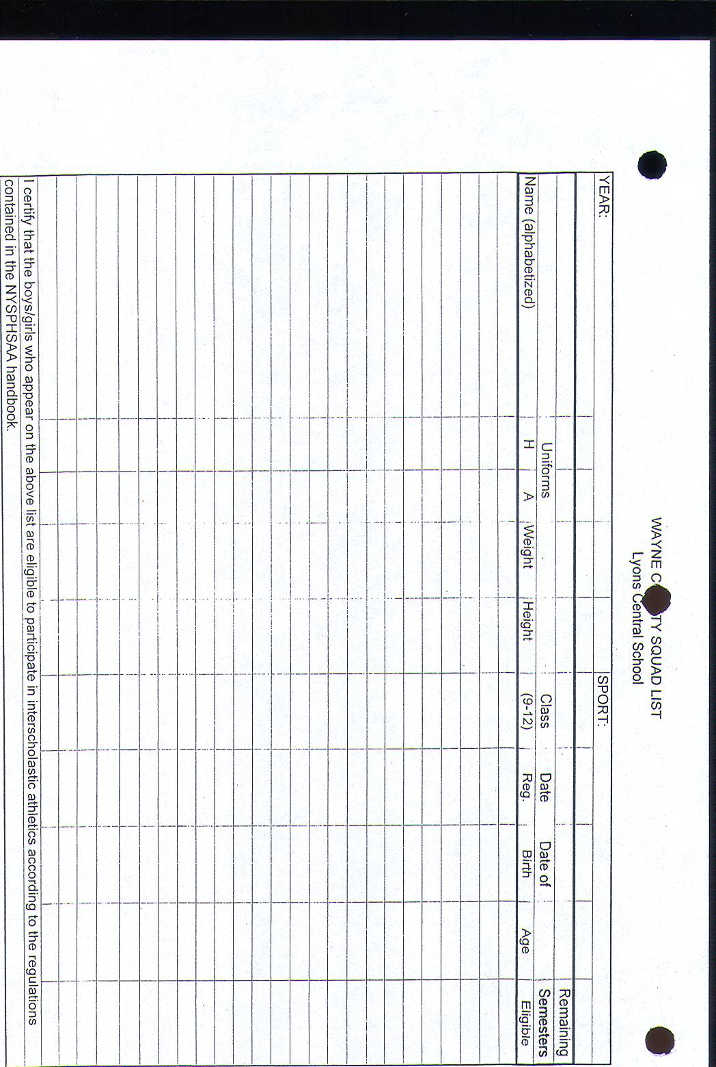

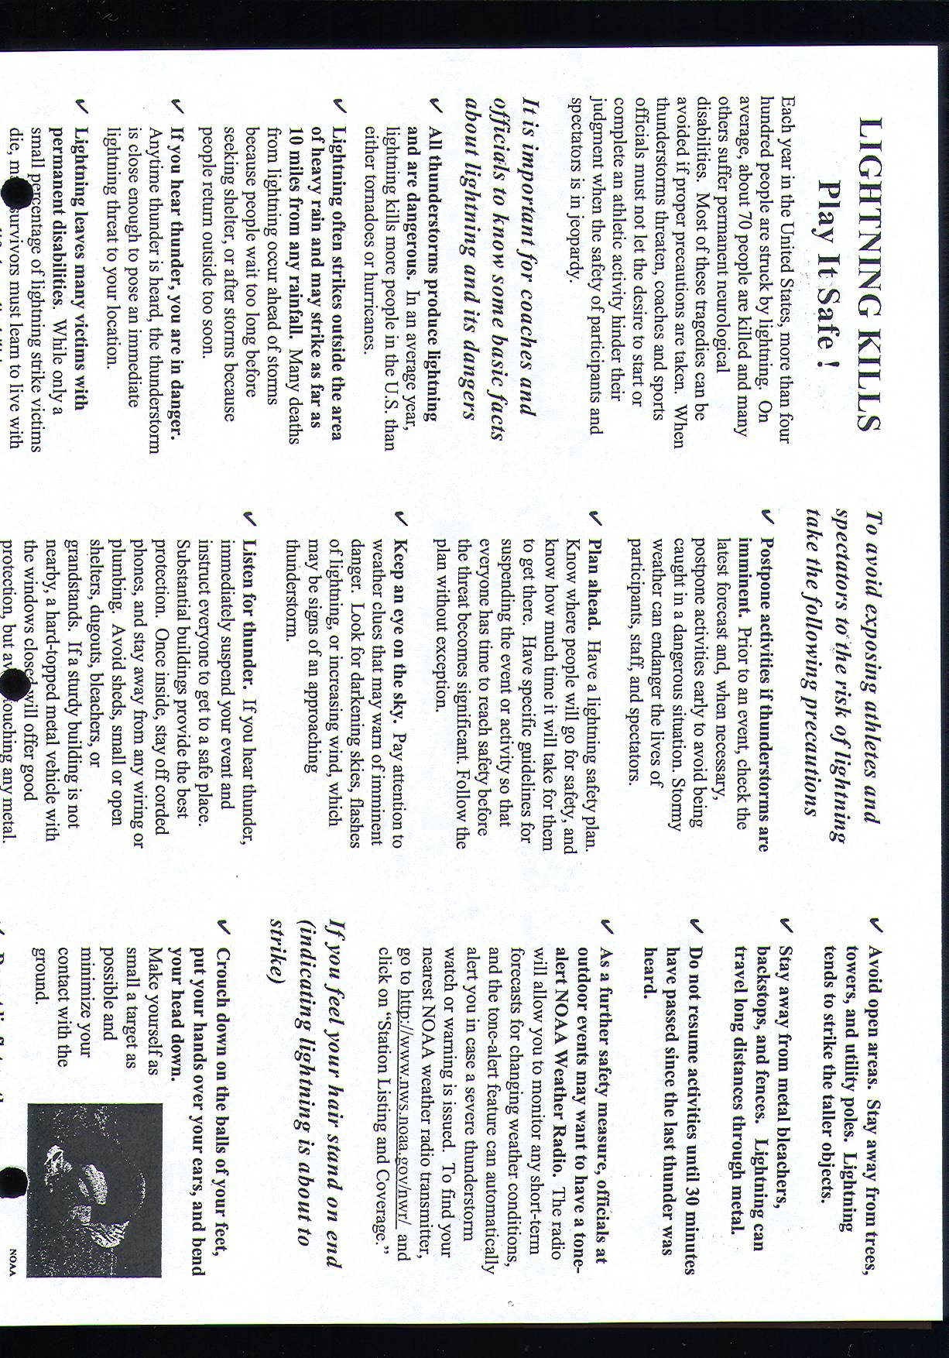

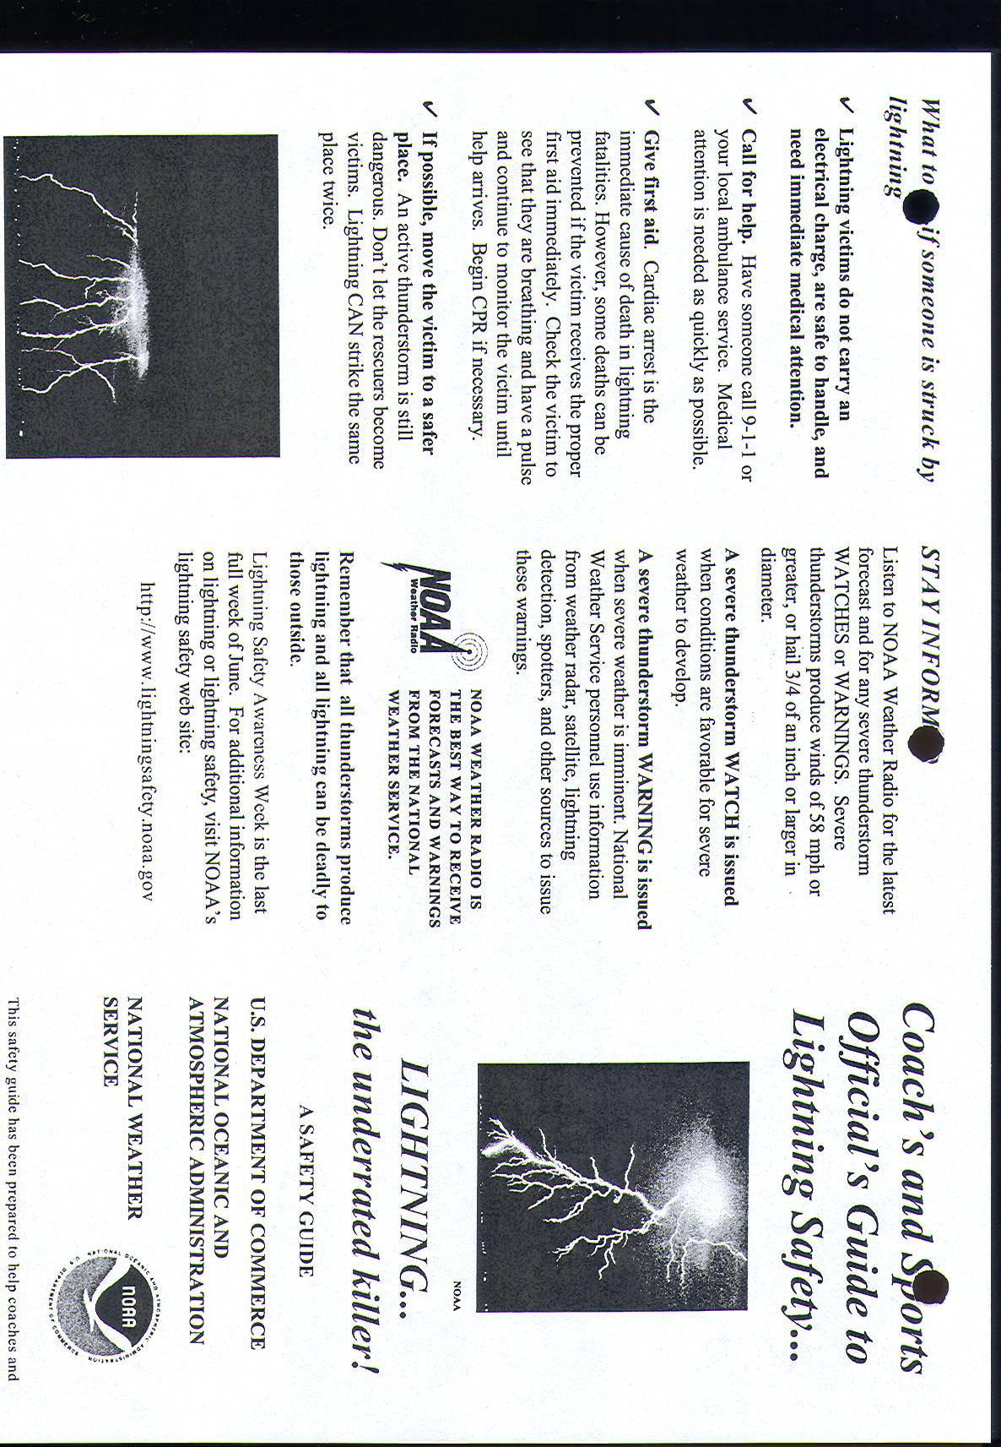

ATHLETIC DEPARTMENT
WORK ORDER FORM

Date: ___________

Description of work to be done:
___________________________________________________________________________________________________________________________________________________________________________________________________________________________________________________________________________________________________________________________________________________________________________________________________________________________________________________________________________________________________________________________________________________________

Signature of Person Requesting: __________________________________________________

------------------------- For Athletic Director’s Use -------------------------

Item Completed: Yes ______ No ______ Date: ____________
Comments:
____________________________________________________________________________________________________________________________________________________________________________________________________________________________________________________________________________________________________________________

Athletic Director’s Signature: ____________________________________________________

Program Evaluations:

- Things that went well
(Schedules/Game Days/Practices/Physicals process/etc.)

- Things that need improvement.
(Schedules/Game Days/Practices/Physicals process/etc.)

- Coaching staff situation

- Plans for next year. (Including Summer Programs)

- Budgets.

- Issues that are a major concern for you

- Changes you would personally like to see

- L.C.C. Information

- Professional Development.

- Other.

